Module 5: Ansible Assignment – 5
Tasks To Be Performed:
1. Create a new deployment of Ansible cluster of 5 nodes
2. Label 2 nodes as test and other 2 as prod
3. Install Java on test nodes
4. Install MySQL server on prod nodes
Use Ansible roles for the above and group the hosts under test and prod.

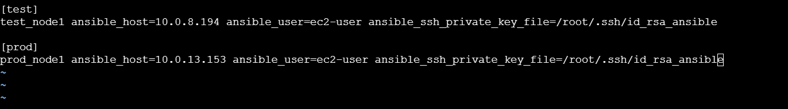
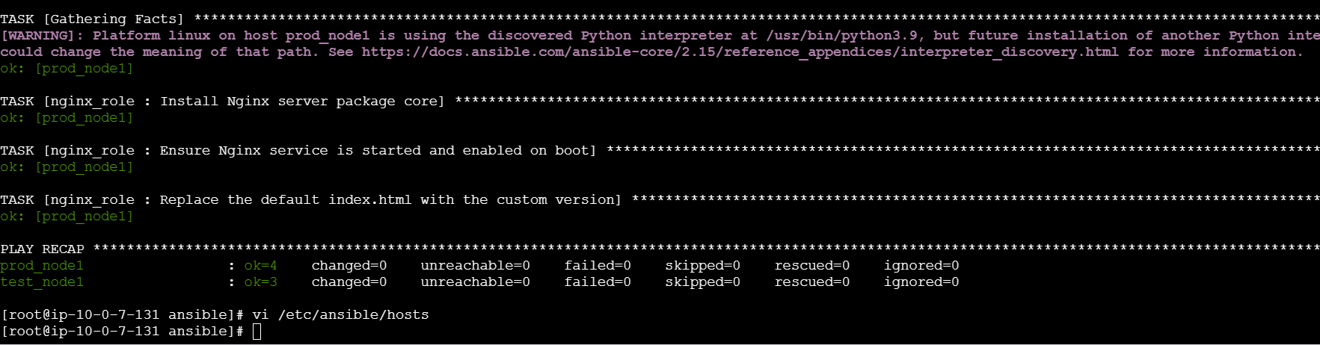

---
# Task 3: Deploy Java on the test node using the first role
- name: Deploy Java Environment on Test Node
hosts: test
become: true
roles:
- apache_role # Calls the Java installation task sequence

# Task 4: Deploy Database Server on the prod node using the second role
- name: Deploy Database Server on Prod Node
hosts: prod
become: true
roles:
- nginx_role # Calls the Database installation task sequence

